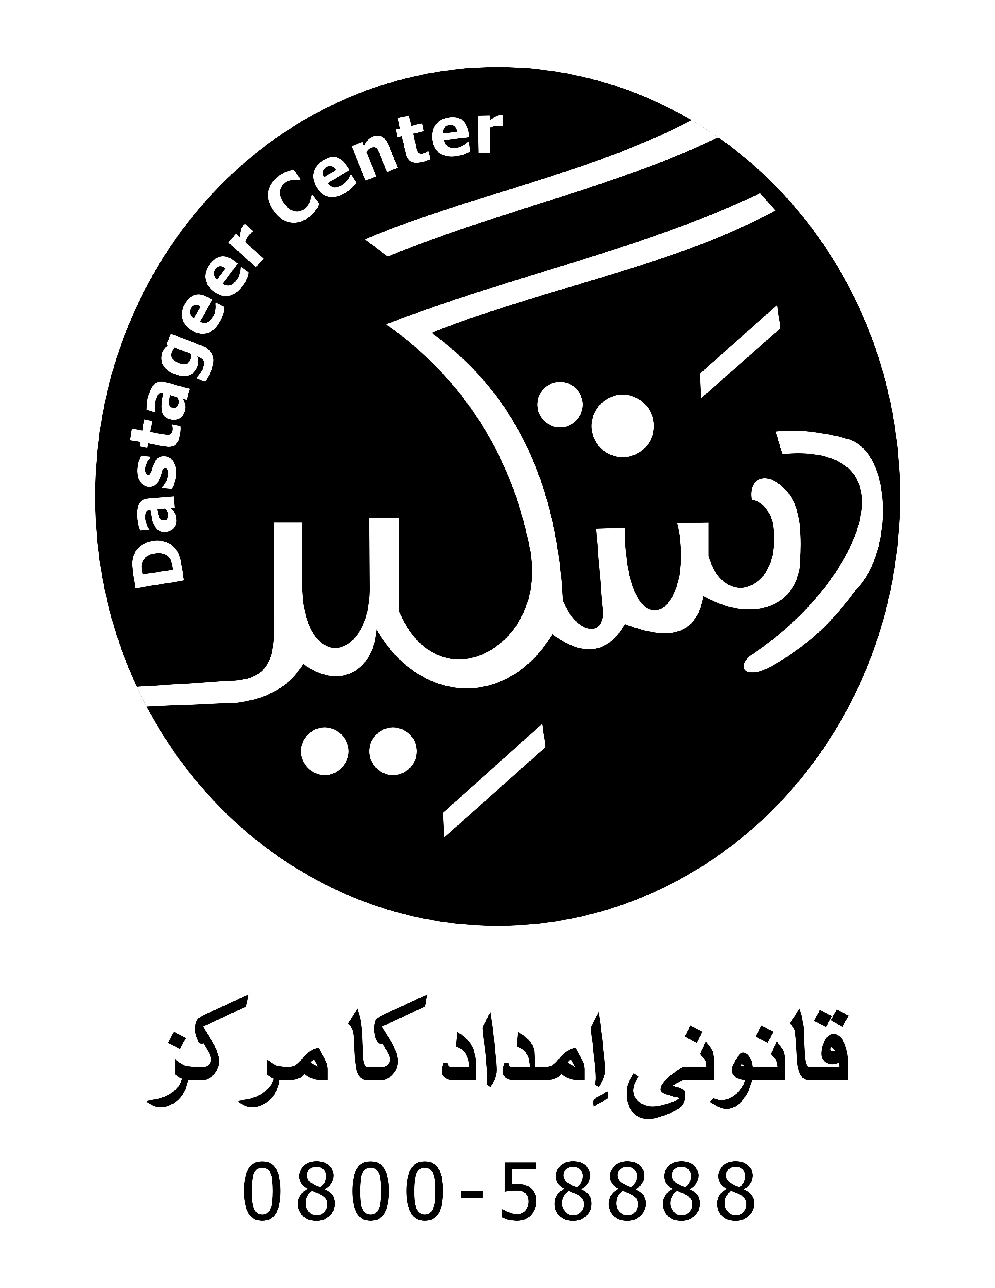

## **Minutes of Joint Network Meeting DLAC Muzaffargarh**

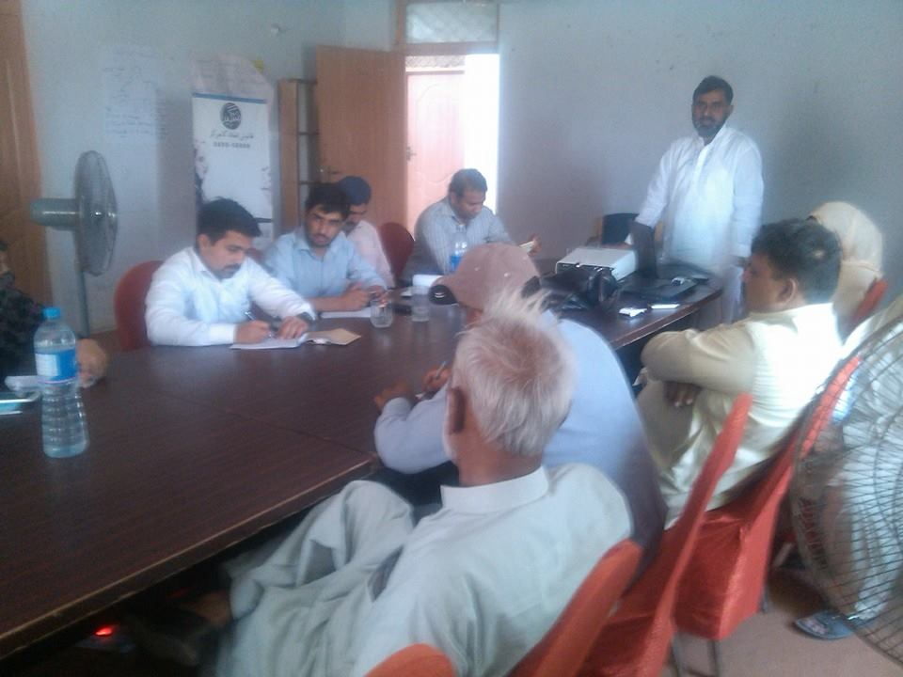

`

Minutes of the Joint Network meeting held on 21st May, 2015 at SYCOP Office Muzaffargarh to share the progress update of the center with other Rights Based Organization (CBOs) and to discuss ways to increase coordination among these organizations as JNN is organized once in a quarter.

**Participants of the Meeting**

Following were participated in the joint network meeting:-

|  |  |  |
| --- | --- | --- |
| # | Name | Organization/Department |
|  | Abdul Rauf | Sanjh Pakistan |
|  | Sarwat Bukhari, Advocate | World Vision International |
|  | Muhammad Ali Azhar, Advocate | World Vision International |
|  | Shahna Abbas Shani | SHEMALE Association |
|  | Saveer Ahmed Khan | Friends Pakistan Organization |
|  | Nauman Masood | Friends Pakistan Organization |
|  | Iftikhar Bukhari | Daily Khabrain |
|  | Nazir Lashari | Daily Express |
|  | Majid Hussain | CPDI |
|  | Waqas Latif | CPDI |
|  | Abdul Razaq | Natural Environment Savers Organization |
|  | Rasheed Ahmed Khan Sherwani | Chairman District Coordination Council NGOs |
|  | Rana Muhammad Afzal | Motheda ULMA & MASHAIKH AMAN Committee |
|  | Touqeer Ahmed | Zia Welfare Council |
|  | Arifa Rafiq | SYCOP |
|  | Mazhar Ashiq | HRDN |
|  | Hafiz Muhammad Akbar Naqash | Idara Adab-o-Saqafat |
|  | Muhammad Afzal Chohan | President SYCOP |
|  | Aamer Ibrahim | Sukh Development |
|  | Qaiser Abbas | Anjuman Tameer-e- Watan |
|  | Waqas Janjua | INP |
|  | Malik Khurram | INP |
|  | Muhammad Ismail Malik | Coordinator DLAC Muzaffargarh |
|  | Shumaila Bokhari | Counselor DLAC Muzaffargarh |

Agenda of the Meeting:

|  |  |
| --- | --- |
| **Activity** | **Responsibility** |
| Progress Update by DLAC | Center Coordinator DLAC |
| Follow-up on Action Point | Center Coordinator DLAC |
| Recommendations for Justice Cluster/Network | Discussion |
| Charter of Justice and Justice Cluster | Discussion |
| Action Points for future meetings | Center Coordinator DLAC |

**Key Discussion Points:**

**Agenda Item 1: Progress Update by DLAC**

Muhammad Ismail Malik, Coordinator DLAC Muzaffargarh gave detailed presentation on progress and update of the DLAC. He briefed that DLAC Muzaffargarh is providing legal aid and victim assistance to vulnerable populations particularly religious and ethnic minorities, survivors of Gender based Violence (GBV) and persons with disability in district Muzaffargarh. Progress was also shared in the form of data including the number of people accessing the center either through walk in or through helpline, number of court cases registered and resolved and psychosocial counseling provided to the clients.

**Agenda Item 2:**

* **Follow-up on Action Point of previous Joint Network** **Meeting on 17 February 2015:**

A follow-up on action points of previous Joint Network Meeting held on 17th February 2015 was shared with the participants as follows:

|  |  |  |
| --- | --- | --- |
| **Action(s) Required** | **Responsibility** | **Status** |
| Share the update of Access to Justice Project and DLAC Muzaffargarh | Coordinator DLAC Muzaffargarh | Update of A2J and DLAC is being shared regularly |
| All network member be updated through SMS in a Mobile Group | Coordinator DLAC Muzaffargarh | In process |
| This network introduced themselves and orienting to other network/organizations so that they may avail the facilities of DLAC | All Network Members | This is being done regularly |
| DLAC should remain in contact with the entire stakeholders and maintain continue coordination. | Coordinator DLAC Muzaffargarh | This is being done regularly |

**Agenda Item 3:**

* **Recommendations for Justice Cluster/Network**

Touqeer Ahmed Khan Sherwani suggested that this network should its name, all the participants suggested following names:-

1. Sustainable Development Network for Justice.(SDNJ)
2. Dastageer Legal Aid Network Muzaffargarh
3. Maddadgar (مددگار)
4. مفت قانونی امداد کا نیٹ ورک
5. تحفظ
6. ڈسٹرکٹ فری لیگل ایڈ نیٹ ورک مظفرگڑھ

The participants will finalize the name in the next meeting. It was also decided that membership form for the network should also be developed for all member organizations.

Shahna Abbas Shani from SHE MALE Association especially participated in the meeting. She highlighted the issue facing by SHE MALE of the district and requested to the network that they should play their role to support them.

Ali Raza, Advocate form Word Vision suggested that Punjab Bar Council may also be part of this network.

It was discussed that the network should have a Secretariat and a focal person for coordination. It was agreed upon that SYCOP will assume the responsibility of Secretariat of this forum and Muhammad Ismail Malik, center coordinator as the Focal Person. The center coordinator thanked the participants for trust and assured of his commitment for the betterment of the network.

**Agenda Item 4:**

**Charter of Justice and Justice Cluster**

The participants suggested for the development of IEC material on Access to Justice and basic human rights to be published and disseminated in relevant community for awareness.

For the first time in the meeting 02 senior media persons participated and they suggested that the strengthening of مصالحتی کونسل(Mediation Council) by the Justice Network/ Forum at village level will facilitate resolve issues at village level instead of going to court.

**Action Points:**

|  |  |
| --- | --- |
| **Action(s) Required** | **Responsibility** |
| Finalization of name of the Network | Coordinator DLAC Muzaffargarh (after approval of TAF/INP) |
| Finalization of TORs of the Network | Coordinator DLAC Muzaffargarh (after approval of TAF/INP) |
| Follow up on previous meeting action points | Coordinator DLAC Muzaffargarh |

All the participants thanked INP and DLAC Muzaffargarh for arranging the joint network meeting and assured to help support DLAC Muzaffargarh in this regard.

.,.,..,.,.,.,.,.,.,.,.,.,.,.,.,